PSYCHOLOGY - PAST AND PRESENT

Early History--Chemistry and physics and biology have long histories as domains of science

Psychology only emerged as a science in the mid-19th century. It emerged from the biological disciplines of

medicine and physiology plus _______________________

**I. WILHELM WUNDT** (1832-1920)

A. Defined psychology as the scientific study of conscious thought

B. 1879 Germany; founded the first university research laboratory

C. Goal - Describe the elements that comprise conscious experience

D. Think of conscious experience as a molecule; the goal is to discover the atoms that

make up the experience. Called structuralism

E. Structuralism was popularized in USA by E.B. Titchner at Cornell University

F. Method - introspection - looking inward; only you can directly

observe your experiences, but assumed the "atoms" were the same.

Required training to prevent "contamination" from meaning.

**II. WILLIAM JAMES** (1842-1910) - at Harvard; Alternative view called functionalism

A. Goal - Describe the function of the mind - what it does

B. Influenced by Darwin’s writings on evolution

C. Text - 1890 - *Principles of Psychology;* it's all there!

**III. SIGMUND FREUD** (1856-1939) Vienna, Austria

A. psychoanalytic theory. Text - 1900 - *The Interpretation of Dreams*

B. Emphasis on

1. unconscious mental processes, primarily sexual and aggressive

2. Personal development, mental illness and therapy

D. Not a researcher; Strong influence in Europe. Less influence in

America because of lack of empirical evidence, but he became a major force in the

way educated people viewed human behavior and motivation.

**IV. JOHN B. WATSON** (1878-1958) - Behaviorism

A. Psychology was defined as the scientific study of behavior; Rejected all

mental concepts.

B. Focus on animal research because it allowed control and because

consciousness was not important.

C. Goal - prediction and control of behavior

D. Dominant American perspective in psychology from 1920s-1960s, but Watson only had a brief

career in psychology

**V. CHANGING PERSPECTIVES** (The 1950s – 1990s)

A. B. F. SKINNER (1904-1990) Radical behaviorism

1. Continued fight against the return of consciousness and Freud's unconscious;

emphasis on environmental control of behavior

2. The environment provides _____________, which directly control _________________.

Reinforcement increases a behavior; punishment decreases a behavior

B. Abraham Maslow and Carl Rogers developed humanism - new view opposing

Psychoanalytic Theory and Behaviorism because they were de-humanizing

1. Behaviorists too focused on _______________ and psychoanalysts too focused on

primitive urges.

2. Emphasis on the unique qualities of human experience: freedom and

____________________ growth; optimistic view. Growth occurs unless

blocked by the environment. Individual thoughts and feelings are primary.

C. COGNITIVE PSYCHOLOGY - 1960s - the “cognitive revolution” - another reaction against

behaviorism; inferences about mental events from observations of behavior, an

information-processing approach

Used the Human-Computer metaphor. Computers process information: Encode

information; Operate on it; Store it; and Retrieve it.

Computers — software and hardware; Humans -- mind and body/brain

Information processing occurs in real-time

Information = symbols, or mental representations of the environment

Cognitive neuroscience examines how information is represented in the brain.

**VI. PSYCHOLOGY TODAY** Definition: the science of behavior and mental processes.

Figure 1.1 Biopsychosocial approach

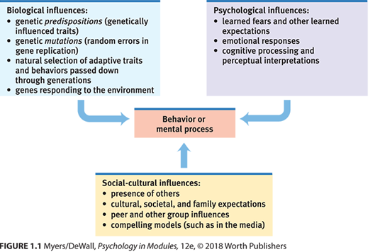

Psychology is both a science - knowledge through basic research and applied research

and a profession - knowledge is used, e.g., to help individuals cope, to help designers build, to help businesses select

**VII. SCIENCE QUESTIONS**

A. Answer to Question 1: ___________________________

Would the person in the street feel comfortable answering this question?

B. Answer to Question 2: ___________________________

Would the person in the street feel comfortable answering this question?

C. Answer to Question 3A: ___________________________

Would the person in the street feel comfortable answering this question?

What is the difference?

Answer to Question 3B: ___________________________

Would the person in the street feel comfortable answering this question?

3A refers to girls and 3B to boys? Would they act the same? _______________________

Where you correct?

What is the point here? Common sense views of human behavior are often wrong.

Psychology examines human behavior through the scientific method.

THINK ABOUT FOR TUESDAY—DOES THE DEMO WITH THE VIDEOS PROVIDE GOOD

EVIDENCE FOR THE POINT? WHY OR WHY NOT?

REMINDERS:

1. HOMEWORK 1 IS DUE SATURDAY AT MIDNIGHT

2. QUIZ 1 ON THE SYLLABUS IS AVAILABLE NOW; DUE ON WEDNESDAY

3. QUIZ 2 BECOMES AVAILABLE SATURDAY MORNING